# How to use Git

Contents

How to use Git 1

In order to get the latest changes made to your master branch 1

How to Rebase 2

<https://docs.microsoft.com/en-us/azure/devops/repos/git/gitquickstart?view=azure-devops&tabs=visual-studio>

Git [branches](https://docs.microsoft.com/en-us/azure/devops/repos/git/branches?view=azure-devops) isolate your changes from other work being done in the project

You make [commits](https://docs.microsoft.com/en-us/azure/devops/repos/git/commits?view=azure-devops) in your local Git repository to save your changes on that branch.

When you are ready to share your changes with the team, you can [push](https://docs.microsoft.com/en-us/azure/devops/repos/git/pushing?view=azure-devops) those changes so that others can reach them. (This will also save your changes to the **remote repository**, i.e. network drive) You can only push changes after you add commits to a branch.

Once you push the changes, you can create a [pull request](https://docs.microsoft.com/en-us/azure/devops/repos/git/pullrequest?view=azure-devops) to let others know you'd like to have the changes reviewed and added to the master branch of the code

## In order to get the latest changes made to your master branch

In this case our ‘master’ is dev rather than master, so we will refer to it as the ‘parent’ branch rather than master branch.

Fetch to get a list of changes (that have been pushed) to the parent branch

Pull to bring (pull) those changes into your branch

Alternatively you can Synch which will do a Fetch and a Pull in one go

1. [Create a branch](https://docs.microsoft.com/en-us/azure/devops/repos/git/branches?view=azure-devops) for the changes you plan to make and give it a name, such as users/jamal/fix-bug-3214 or cool-feature-x. For more branching guidance, see [Adopt a Git branching strategy](https://docs.microsoft.com/en-us/azure/devops/repos/git/git-branching-guidance?view=azure-devops)
2. [Commit changes](https://docs.microsoft.com/en-us/azure/devops/repos/git/commits?view=azure-devops) to your branch. People often have multiple commits for a bug fix or feature.
   1. This is a save to your local drive.
3. [Push your branch](https://docs.microsoft.com/en-us/azure/devops/repos/git/pushing?view=azure-devops) to the remote repository.
   1. This will save to network drive. Is this all that happens?
4. [Create a pull request](https://docs.microsoft.com/en-us/azure/devops/repos/git/pullrequest?view=azure-devops) so other people can review your changes. To incorporate feedback, you might need to make more commits and push more changes.
   1. All this does is send out a code review request?
   2. And a build
5. [Complete your pull request](https://docs.microsoft.com/en-us/azure/devops/repos/git/pullrequest?view=azure-devops) and resolve any merge conflicts from changes other people made after you created your branch.
   1. This will save your changes to the master(dev?) branch
   2. Does this also delete your branch?
      1. If ticked
6. 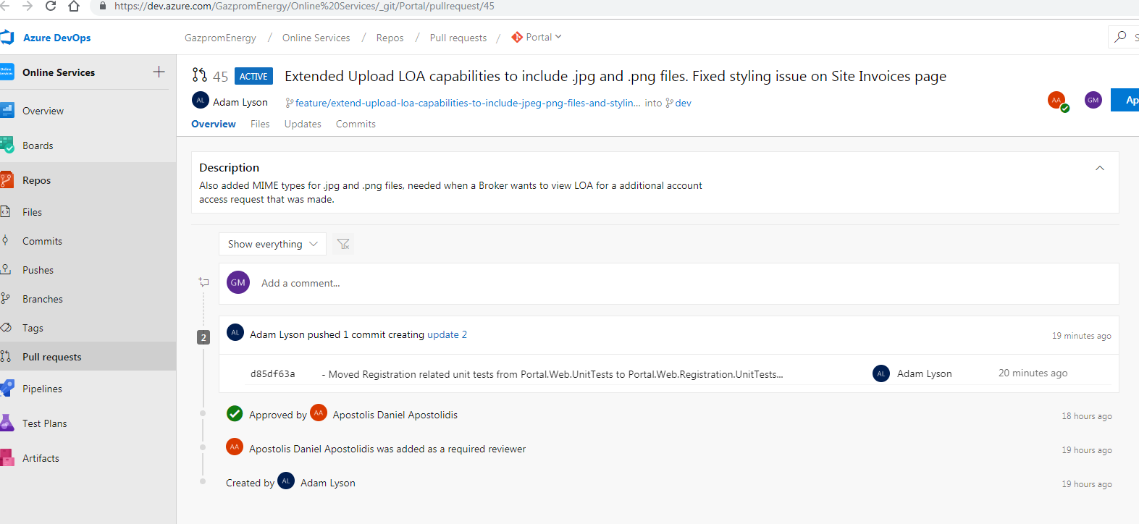

This shows the pull being done, but does not mention when the pull request happened?

## How to Rebase

This is best done via the command line.

Using Windows Explorer, go to the repository folder, this will have .git folder in it.

Right click and select Git Bash Here

A command window will be opened with a branch name at the end in blue text. If this is not present, then you are in the wrong folder

Assuming you are rebasing a branch called acceptance-test/my-changes onto a parent branch called Dev, you would type the following:

Git checkout Dev

Message will say

“Switched to branch ‘dev’”

Git pull

If your local dev branch is already up to date with the remote dev branch, then message will say

“Already up to date”

Git checkout acceptance-test/my-changes

Message will say

“Switched to branch ‘acceptance-test/my-changes’”

Git rebase dev

If your branch is up to date with local copy of dev, then message will say

“Current branch acceptance-test/my-changes is up to date”